A

**Your name**

Project Report On

ONLINE SHOPPING SYSTEM

Submitted in partial fulfillment of the requirement for the VIII semester

## Bachelor of Technology in Computer Science Engineering

By

**Your Name**

**Assistant Professor**

**Department of Computer Science Engineering**



**DEPARTMENT OF COMPUTER SCIENCE ENGINEERING GRAPHIC**

# STUDENT’S DECLARATION

We the students of VIII semester B.Tech. Your University Name____, ABC(your name) declare that he technical Project work entitled “**ONLINE SHOPPING SYSTEM”** has been carried out and submitted in the partial fulfilment of the course requirements for the award of degree in B.Tech. Computer Science Engineering at ________during the academic year 2023-24. The matter submitted in the synopsis has been not submitted to any other university or institutions for the award of any other degree or diploma in the concerned stream.

### Your name

**Place: Date:**

# CERTIFICATE

This is to certify that the dissertation report entitled, “Online Shopping System” submitted by your name , India, is a record of bonafide project work carried out by them under our supervision and guidance and is worthy of consideration for award of Degree of Bachelor of Technology in Computer Science Engineering of the Institute.

**Project Guide:** Mr. __________

Assistant Professor

Department Of Computer science Engineering

**Project Coordinator:** Mr. ___________

Assistant Professor

Department Of Computer science Engineering

**Head Of The Department:** _____________

HOD / Asst. Professor

Department Of Computer Science Engineering ____________

Preface

Your co-operation in form of suggestions and comments are most welcome, to First of all I would like to say that project is very essential part of our educational quota. If we are going only for theory parts, it can not give us perfect knowledge.

This project report of Online Library Management System Web   
Site is present against you for project as a subject in 8th semester in   
B TECH.

This web site is developed for study purpose of the Computer’s Student. It provides computer e-book It also provide’s educational software to students this web site It requires only registeration of the Buyers which is also free. For that student must have valid email account like yahoo rediff hotmail etc. This online library management system web site is developed in JSP language.

This web site is quite easy in operating so that any student can able to use it easily.

Improve s any knowledge and project.

2

ACKNOWLEDGEMENT

We wish to convey our sincere gratitude to the staff of Arjun College for giving us advice and guidance during development of project.

No serious and lasting achievement or success, one can ever achieve without the help of friendly guidance and cooperation of all people involved in this work.

First of all I am grateful to Prof.abc for helping us   
so much and showing his keen interest and co-operation in completing   
this work. Then I would like to thank my lab faculties also for co-  
ordination.

I would also like to thanks my Parents, friends and all members of my family for encouraging me for this work.

3

DECLARATION

Your name the student of 8th semester of B TECH

(b teach) at colleage name . declares against you that this web site is developed by us and has been carried out under the supervision and guidance of

Guide name

4

Content

|  |  |
| --- | --- |
| S  N | Title |
| 1 | Introduction |
|  | 1.1 Project Profile |
|  | 1.2 Introduction about project |
|  |  |
| 2 | About Technology |
|  | 2.1 HTML |
|  | 2.2 CSS |
|  | 2.3 JSP |
|  | 2.4 JavaScript |
|  | 2.5 MySQL |
|  | 2.6 Apache |
|  | 2.7 AJAX |
|  | 2.8 JQuery |
|  |  |
| 3 | System Development Life Cycle |
|  |  |
| 4 | System Analysis |
|  | 4.1 Feasibility Study |
|  | 4.2 Project |
|  |  |
| 5 | Introduction About Front End |
|  |  |
| 6 | Introduction About Back End |
|  |  |
| 7 | Design Methodology |

5

|  |  |
| --- | --- |
|  |  |
| 8 | GNATT Chart |
|  |  |
| 9 | E-Commerce Concertino |
|  |  |
| 10 | Nature Of Project |
|  |  |
| 11 | Project Requirement |
|  |  |
| 12 | Flow Chart |
|  |  |
| 13 | Data Dictionary |
|  |  |
| 14 | Screenshot Of Project |
|  |  |
| 15 | Testing $ Implementation |
|  |  |
| 16 | Testing objectives |
|  |  |
| 17 | Library management.com information |
|  |  |
| 18 | Library management Account and Registration |
|  |  |
| 19 | Order processing |
|  |  |
| 20 | Future enhancements |
|  |  |
| 21 | References |

6

Introduction

1.2 PROJECT PROFILE

Project Title   
Project Type

Programming Language

Front End Utility

Back-End

Utility

Documentation Tool

Designing Tool

Duration

Project

Guide(Internal)   
 Developed By

Submitted to

online libray management system

Web Based Application

JSP and servlet ,core java 8

JSP5, HTML5,CSS3, JavaScript, JQuery MySQL Query Browser

Microsoft ® Word 2019

Dreamweaver CS3/CS5 and Photoshop CS5

3 months

abc

abc

COLLAGE colleage name

7

1.2 INTRODUCTION ABOUT PROJECT

This project is followed the concept of the E-commerce thoroughly. This project is developed to sell the products on line of various Book Collection Category mentioned in the project...

This project definitely helps the user to buy anything from the internet because in the ONLINE BOOK SHOP you can purchase anything with clicking of some button of the mouse and pressing some keys of the keyboard & entering your credit card no. in that.

By using this project, the user can save his or her time by purchasing   
the product which time they are wasting by roaming in the market.   
From here, they can get most probably all the things they want besides   
fast moving Entertainment goods. They have various choices in the one   
Collection.

8

PROJECT OVERVIEW

This project is followed the concept of the Management thoroughly. This project is developed to sell the products on line of various Book Collection Category mentioned in the project.

This project definitely helps the user to buy anything from the internet   
because in the ONLINE LIBRARY MANAGEMENT SYSTEM you can   
purchase anything with clicking of the some button of the mouse and   
pressing some keys of the keyboard & entering your credit card no. in   
that.

By using this project, the user can save his or her time by purchasing   
the product which time they are wasting by roaming in the market.   
From here, they can get most probably all the things they want besides   
fast moving Entertainment goods. They have various choices in the one   
Collection.

9

1:ABOUT TECHNOLOGY

2.1 HTML



A simple markup language used to create hypertext documents that are portable from one platform to another. HTML files are simple ASCII text files with codes embedded indicated by markup tags) to denote formatting and hypertext links.

Many people who use HTML to create Web pages or other documents find Notepad a useful tool for writing in HTML. Because Notepad supports only very basic formatting, you cannot accidentally save special formatting in documents that need to remain pure text. This is especially useful when creating HTML documents for a Web page because special characters or other formatting may not appear in your published Web page or may even cause errors.

Many word processors provide additional tools or converters to help you create   
HTML documents. But, if you are creating simple pages or if you want to make a few   
quick changes, Notepad opens files quickly. Also, Notepad shows all of the HTML

10

tags so you can troubleshoot your page. Not all word processors or converters make the HTML code available.

Much of the e-mail you receive is created using a simple computer language called HTML. HTML makes it possible to use pictures, fancy backgrounds, icons, and different kinds of text in e-mail. But HTML can also allow hackers to hide viruses in e-mail. When you read your e-mail in plain text, you prevent the viruses from being transmitted to your computer.

11



2.2 CSS

Cascading Style Sheets, CSS for short, represent a major breakthrough in how Web page designers work, by expanding their ability to improve the appearance of their Web pages - the documents that people publish on the Web.

CSS is a simple mechanism for adding style to HTML documents. With CSS, one   
can specify such styles as the size, color, and spacing of text, as well as the placement   
of text and images on the page. Plus a whole lot more. This is done via the use of style   
sheets. A style sheet is a set of stylistic rules that describe how HTML documents are   
presented to users.

A key feature of CSS is that style sheets can cascade. That is, several different style sheets can be attached to a document and all of them can influence the presentation of the document. In this way, the author can create a style sheet to specify how the page should look, while the reader can attach a personal style sheet to adjust the appearance of the page for human or technological handicaps, such as poor eyesight or a personal preference for a certain font.

12

CSS is a simple language that can be read by humans - in contrast to some   
computer languages. Perhaps even more important, however, is that CSS is easy to   
write. All you need to know is a little HTML and some basic desktop publishing   
terminology: CSS borrows from desktop publishing terminology when expressing   
style.

A substantial amount of texts were consulted during the development process,   
many of which will not be referenced directly since they served only as background   
reading. What follows is a review of some of the key texts used in the duration of this   
project.

13

2.3 JSP and Servlets

• The full form of JSP is “Hypertext Preprocessor”. Its original name was “Personal   
 Home Page”

• Rasmus Lerdorf software engineer, Apache team member is the creator and   
 original driving force behind JSP. The first part of JSP was developed for his   
 personal use in late 1999.

• By the middle of 1999, JSP was being used on approximately 50,000 sites   
 worldwide.

• JSP is server-side scripting language, which can be embedded in HTML or used as   
 a stand-alone.

14

• JSP doesn’t do anything about what a page looks and sounds like. In fact, most of   
 what JSP does is invisible to the end user.

• Someone looking at a JSP page will not necessarily be able to tell that it was not   
 written purely in HTML, because usually the result of JSP is HTML.

• JSP is an official module of Apache HTTP Server.

• JSP is fully cross-platform, meaning it runs native on several flavors of UNIX, as   
 well as on Windows and now on Mac OS X.

➢ Why JSP?

• JSP is compatible with almost all.

• JSP runs on different platforms (Windows, Linux, UNIX, etc.)

• Resource servers used today (Apache, IIS, etc.)

• JSP is FREE to download from the official JSP: [www.Jsp.net](http://www.php.net/) JSP is easy to learn   
 and runs efficiently on the server side

➢ Advantages of JSP

15

• Cost: JSP costs you nothing. It is open source software and doesn’t need to   
 purchase it for development.

• Ease of Use: JSP is easy to learn, compared to the others. A lot of Ready-made   
 JSP scripts are freely available in market so, you can use them in your project or   
 get some help from them.

• HTML- Support: JSP is embedded within HTML; In other words, JSP pages are   
 ordinary HTML pages that escape into JSP mode only when necessary. When a   
 client requests this page, the web server preprocesses it. This means it goes   
 through the page from top to bottom, looking for sections of JSP, which it will try   
 to resolve.

• Cross-platform compatibility: MySQL run native on every popular flavor of UNIX   
 and windows. A huge percentage JSP and of the world’s HTTP servers run on one   
 of these two classes operating system.

• JSP is compatible with the three leading Web servers: Apache HTTP Server for   
 UNIX and Windows, Microsoft Internet Information Server, and Netscape   
 Enterprise Server. It also works with several lesser-known servers, including Alex

16

Blits’ fhttpd, Microsoft’s Personal Web Server, OL Server and Omnicentrix’s Omni   
server application server.

• Stability: The word stable means two different things in this Context:

▪ The server doesn’t need to be rebooted often

▪ The software doesn’t change radically and incompatibly from release to release.

To our advantage, both of these apply to both MySQL and JSP.

Speed: JSP is pleasingly zippy in its execution, especially when compiled as and   
Apache module on the UNIX side. Although it takes a slight performance hit by   
being interpreted rather than compiled, this is far outweighed by the benefits JSP

drives from its status as a Web server module

17

2.4 JAVA SCRIPT

➢What is JavaScript?

• JavaScript was designed to add interactivity to HTML pages.

• JavaScript is a scripting language. (a scripting language is a lightweight

programming language)

• A JavaScript consists of lines of executable computer code.

• A JavaScript is usually embedded directly into HTML pages.

• JavaScript is an interpreted language. (means that scripts execute without

preliminary compilation)

• Everyone can use JavaScript without purchasing a license.

18

➢Are Java and JavaScript the Same?

• NO! Java and JavaScript are two completely different languages in both concept   
 and design!

• Java (developed by Sun Microsystems) is a powerful and much more complex   
 programming language - in the same.

• Category as C and C++.

➢ What can a JavaScript Do?

• JavaScript gives HTML designers a programming tool - HTML authors are normally   
 not programmers, but JavaScript is a scripting language with a very simple syntax!   
 Almost anyone can put small "snippets" of code into their HTML pages.

• JavaScript can put dynamic text into an HTML page - A JavaScript statement like   
 this: document. Write ("<h1>" + name + "</h1>") can write a variable text into an   
 HTML page.

• JavaScript can react to events - A JavaScript can be set to execute when something   
 happens, like when a page has finished loading or when a user clicks on an HTML   
 element.

19

• JavaScript can read and write HTML elements - A JavaScript can read and change   
 the content of an HTML element.

• JavaScript can be used to validate data - A JavaScript can be used to validate form   
 data before it is submitted to a server, this will save the server from extra   
 processing.

• JavaScript can be used to detect the visitor's browser - A JavaScript can be used to   
 detect the visitor's browser, and - depending on the browser - load another page   
 specifically designed for that browser.

• JavaScript can be used to create cookies - A JavaScript can be used to store and   
 retrieve information on the visitor's computer.

20



2.5 MYSQL

Mysql Another open source favorite, Mysql is the database construct that enables JSP and Apache to work together to access and display data in readable format to a browser.It is a Structured Query Language server designed for heavy loads and processing of complex queries.

As a relational database system, Mysql allows many different tables to be joined together for maximum efficiency and speed.

• Some of most popular features of Mysql are as follows:

• Multiple CPUs usable through kernel threads.

• Multiple-platform operation.

• Numerous column types cover virtually every type of data.

• Group functions for mathematical calculations and sorting.

• Function names that do not affect tables and column names. A Password and user   
 verification system for added security.

• International error reporting usable in many different countries.

21

2.6 APACHE

Apache acts as your Web server. Its main job is to parse any file requested by a   
browser and display the correct results according to the code within that file. Apache   
is quite powerful and can accomplish virtually any task that you, as a Webmaster,   
require.

•

•

•

•

•

•

Password-protected pages for a multitude of users. Customized error pages.

Display of code in numbers levels of HTML, and the capability to determine at what level the browser can accept the content.

Usage and error logs in multiple and customizable formats. Virtual hosting for different IP addresses mapped to the same server. URL aliasing or rewriting with no fixed limit.

22

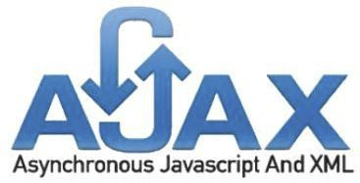

2.7 AJAX

• AJAX = Asynchronous JavaScript and XML.

• AJAX is a technique for creating fast and dynamic web pages.

• AJAX allows web pages to be updated asynchronously by exchanging small   
 amounts of data with the server behind the scenes. This means that it is possible to   
 update parts of a web page, without reloading the whole page.

• Classic web pages, (which do not use AJAX) must reload the entire page if the   
 content should change.

23



2.8 JQUERY

• JQuery is a new kind of JavaScript Library.

• JQuery is a fast and concise JavaScript Library that simplifies HTML document   
 traversing, event handling, animating, and Ajax interactions for rapid web   
 development.

• JQuery is designed to change the way that you write JavaScript.

1.The System Development Life Cycle method is classically through of as the set   
 of activitis. The analysts, designer, and users carry out to develop and implement   
 an information system. This method consists of six steps. In most business   
 situations the activities are all closely related. Usually inseparable and even the   
 order of the steps in these activities may be difficult to determine. Different parts   
 of the project can be in various phases at the same time, with some components   
 undergoing analysis while others are at advanced design stages.

24

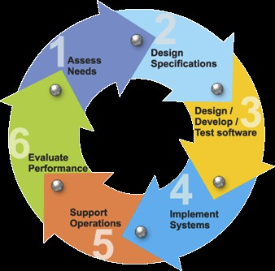

3.SYSTEM DEVELOMENT LIFE CYCLE

The System Development Life Cycle model was developed as a structured   
approach to information system development that guides all the processes involved   
from an initial feasibility study through to maintenance of the finished application.

SDLC models take a variety of approaches to development.

25

System development life cycle models include:

The waterfall model:

This is the classic SDLC model, with a liner and sequential method that has goals for each development phase. The waterfall model simplifies task scheduling, because there are no iterative or overlapping steps. One drawback of the waterfall is that it does not allow for much revision.

Rapid Application Development (RAD):

This model is based on the concept that better products can be developed more quickly by using workshop of focus groups to gather system requirement; prototyping and reiterative testing of designs; rigid adherence to schedule; and less formality of team communications as reviews.

Join Application Development (JAD):

This model involves the client or end user in the design and development of an application, through a series of collaborative workshops called JAD sessions.

26

The prototyping model:

In this model, a prototype (an early approximation of a final system or product) is built, tasted, and then reworked as necessary until an acceptable Proto type is finally achieved from which the complete system or product can now be developed.

Synchronize-and-stabilize:

This model involves teams working in parallel on individual application modules, frequently synchronizing their code with that of other teams and stabilizing code frequently throughout the development process.

The spiral model:

This model of development combines the features of the prototyping model the waterfall model. The spiral model is favored for large, expensive, and complicated projects.

27

4. System analysis

4.1 FEASABILITY STUDY

A feasibility study is undertaken to determine the possibility or probability of either improving the existing system or developing a completely new system.

It helps to obtain an overview of the problem and to get rough assessment of whether feasible solution exists.

This is essential to avoid committing large resources to a project and then repent on it later.

➢ Need for Feasibility Study:

The feasibility study is needed to

(1) Answer the question whether a new system is to be installed or not?

(2) Determine the potential of the existing system.

(3) Improve the existing system.

(4) Know what should be embedded in the new system.

(5) Define the problems and objective involved in a project.

(6) Avoid costly repairs at a later stage when the system is implemented.

(7) Avoid crash implementation of a new system.

28

(8) Avoid the ‘Hardware Approach’ i.e. getting a computer first and then deciding

how to use it. There are three aspects in feasibility study portion of the

preliminary investigation.

(1) Technical feasibility.

(2) Economic feasibility and

(3) Operational feasibility of the project.

(1) Technical Feasibility :

Technical Feasibility determines whether the work for the project be done with the   
present equipment, current procedures, existing software’s technology and available   
personnel?

If new technology is needed then what alternatives will be needed in the present structure and work ethos?

This will require a close examination of the present system.   
The technical feasibility should ask questions related to:

1) Adequacy of available technology.

2) Adequacy of hardware.

3) Available of computer.

4) Operating time and support facilities, etc.

Technical feasibility determines whether the technology needed for the proposed system is available and how it can be integrated within the Purchase, Sales and Inventory System. Technical evaluation must also assess whether the existing system can be upgraded to use the new technology and whether the Purchase, Sales and Inventory System have the expertise to use it.

29

The technical feasibility in the proposed system deals with the technology used in the system. It deals with the hardware and software used in the system whether they are of latest technology or not. It happens that after a system is prepared a new technology arises and the user wants the system based on that technology. Thus it is important to check the system to be technically feasible.

(2) Economic feasibility:

Economic feasibility looks at the financial aspects of the project. Economic feasibility concerns with the returns from the investments in a project. It determines whether it is worthwhile to invest the money in the proposed system. It is not worthwhile spending a lot of money on a project for no returns.

To carry out an economic feasibility for a system, it is necessary to place actual money value against any purchases or activities needed to implement the project. The Purchase, Sales and Inventory System plans to acquire the necessary hardware and software require for the system and there is no hindrance whether economical or otherwise towards its purchase.

30

(3) Operational feasibility:

Operational feasibility covers two aspects. One is the technical performance aspect and other is the acceptance within the Purchase, Sales and Inventory System. Operational feasibility determines how the proposed system will fit in the current operations and what, if any job restructuring and retraining may be needed to implement the system.

In the system operational feasibility checks, whether the user who is going to use the system is able to work with the software’s with which the system is coded and also the mind of the user going to use the system.

4.2 PROJECT

• Project means that what are the reasons for when the analyst created or being, for a   
 new system. The requests for information system are typically motivated by one of   
 the following object:

• To achieve these object, the firm typically undertake project for one or more of the   
 following reasons, o Capability o Controls o Communication o Coast

o Competitiveness

31

5. Introduction about front End

➢ JSP (Hypertext Preprocessor)

Hypertext Preprocessor is Server Side Scripting environment that can be used   
to create and run dynamic Interactive, high performances web server applications.

When script run on the server rather than on the client, the web server does all the   
works involved in generation of the Hypertext Markup Language (HTML) that is sent   
back to browsers. The browsers need not process a web page; the server does all the   
processing.

Only a working knowledge of HTML is required to being use JSP.

JSP stands for “JSP: Hypertext Processor” is a server-side HTML-embedded scripting language. You write an HTML script with some embedded code to do.

Something the JSP code is allowing you to jump into and out of JSP mode. What   
distinguishes JSP from something like client side JavaScript is that the code is   
executed on the server? If you were to have a script similar to the above on your server,   
the client would receive the result of running script, with no way of determining what   
the underlying code may be. You can even configure your web server to process all   
your HTML files with JSP, and then there’s really no way that users can tell what you   
have up your sleeve

32

➢Why to use JSP?

JSP runs on different platforms (windows, Linux, Unix etc.)

JSP is compatible with almost all servers used today (Apache, IIS, etc.) JSP is free to download

JSP runs efficiently on the server side.

➢What can JSP do?

At the most basic level, JSP can do anything any other CGI program can do,   
such as collect form data, generate dynamic page content, or send and receive cookies.

Perhaps the strongest and most significant feature in JSP is its support for a wide   
range of databases. Writing a database-enabled web page is incredibly simple. The   
following databases are currently supported: JSP also has support for talking to other   
services using protocols such as IMAP, SNMP, NNTP, POP3, or even HTTP.

You can also open raw network sockets and interact using other protocols.

➢What Is HTML?

Hypertext Markup Language is shortly known as HTML that can use to create   
interactive, online pages.HTML is a system of code that identify parts and

33



characteristics of document.HTML is made up of tags and attributes. That work together to identify document parts and tell browses how to display them.

➢What can you do with HTML?

HTML has expanded to include many other uses like:   
 Developing Intranet or Extranet sites

Developing Help Files.

Developing Network Application.

➢Tools for HTML:

If you are developing a web page using HTML you need two basic tools as follows:

An HTML editor:

This is used to create and save HTML documents.

A Web browser:

This is used to view and test HTML documents.

34

6. Introduction about back end

➢What is MYSQL?

MYSQL is a SQL (Structured Query Language) Database server. SQL is the most popular database language in the world. MYSQL is a client server implementation that consists of a server demon MySQL and many different client programs/libraries. The main goals of MySQL are speed and robustness.

The base upon which MySQL is built is a set of routines that have been used in a highly demanding production environment for many years. While MySQL is activity developed, it already offers a rich and highly useful function set. The official way to pronounce MySQL is ‘My EssQue Ell’ (Not MY-SEQUEL).

➢The Main Features of MYSQL:

• Fully multi-threaded using kernel threads. That means that it easily can use multiple   
 CPU if available.

• Work on a lot of different platforms.

• SQL functions are implemented thought a very optimize class library and should be   
 as fast as they can get! Usually there shouldn’t be any memory allocation at all after   
 the query initialization.

35

A privilege and password system with is very flexible and secure password since all password traffic on the net are encrypte

3.DESIGN METHODOLOGY

Collecting all the information that was obtained from requirement, the next step was to design the system.As mentioned earlier system is to be implemented as a website. This was the prime consideration when designing the system. As this system meant for any one of the system should not be complex and should be under stable for any person who doesn’t have web based background. The system design was developing three different yet interrelated dimensions.

The dimensions in which the system was designed are

1) Data Design

2) Architecture Design

3) Interface Design

1) Data Design

The Data Design transforms the information domain model created during analysis   
into data structure that will be required to implement the project. Then object and   
relationships defined in the entity relationship diagram and detailed data content   
depicted in the data dictionary provide the data basis for data design activity. Part of

36

the data design may occur in conjunction with the design of software architecture. The design of data and its data structure is shown in data dictionary.

2) Architectural Design

The architecture of the project is an important part of overall design of software. Architecture of the project helps us to

1) Analyze the effectiveness of the design in meeting its stated requirement.

2) Consider architectural alternative at a stage when making design changes is still   
 relatively easy, and

3) Reducing the risk associated with the construction of the software.

There are various architectural patterns for designing a project such as data center architecture, data flow architectures, call and return architectures, object oriented architectures and layered architectures.

Different architectural designs are used for different type of projects. For my project   
the architectural design which best fitted my project requirements was Object Oriented   
Architectures and Data Centered Architectures. This type of architectures is best suited   
when data store (e.g. database) resides at the center of this architecture and is accessed   
frequently by other components that update, add, delete or otherwise modify data   
within the store. This type of architecture promotes inerrability. That is, existing   
components can be changed and new client components can be added to the

37

architecture without concern about other clients. Each client is independent of the data of other clients. Hence the type of data centered architecture is passive.

The data centered architecture for my project is shown in the figure below. In this   
architecture, the central entity is the database where the problems of the user and the   
solutions are stored. When clients submit his problem, there is not much computation   
taking place. But instead data is validated and stored in the database. The support staff   
personnel logs in his account and see all the problem details that are fetched from the   
database. Then support staff personnel staff replies the problem and that reply again is   
stored in the database for the reference of client. So here there is not computation   
taking place on the data. Just simple validation takes place on the data and if the data   
is valid, it is stored in the database unmodified. Hence the data centered architecture is   
best suits the needs of this project

38

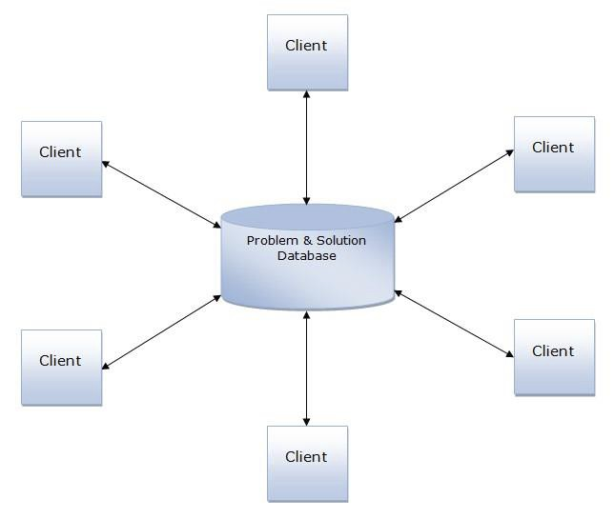

3) Interface Level Design

There are 3 golden rules when constructing the interface of a software project. The rules are as follows: 1) Place the user in control

2) Reduce the memory load of user

3) Make the interface consistent

Since this project is to be implemented as website, the interface has to be consistent   
with the overall design of the site. Any person with the technical or non technical

39

background can visit the site and can submit his problem. So the interface has to design such a way that it can be understood by any type of user whether novice or professional. The interface of the site is the forms that are given to the user to be filled up. The user is presented with the form which contains few fields which are supported by brief text which specifies what types of data are to be filled in the form.

These three rules were kept in mind while designing the interface for the client as well as support staff personnel.

40

3. GNATT CHART

➢Time Diagram:

|  |  |  |  |  |  |  |  |  |  |  |  |  |
| --- | --- | --- | --- | --- | --- | --- | --- | --- | --- | --- | --- | --- |
| Project Title | Online e Library Management System | | | | | | | | | | | |
| July | | | | august | | | | September | | | |
| Work | Week | | | | Week | | | | Week | | | |
| 1 | 2 | 3 | 4 | 1 | 2 | 3 | 4 | 1 | 2 | 3 | 4 |
| Find Definition |  |  |  |  |  |  |  |  |  |  |  |  |
| Practical Demo |  |  |  |  |  |  |  |  |  |  |  |  |
| Feasibility Study |  |  |  |  |  |  |  |  |  |  |  |  |
| System Analysis |  |  |  |  |  |  |  |  |  |  |  |  |
| Database Design |  |  |  |  |  |  |  |  |  |  |  |  |
| System Design |  |  |  |  |  |  |  |  |  |  |  |  |
| Coding |  |  |  |  |  |  |  |  |  |  |  |  |
| Other Application |  |  |  |  |  |  |  |  |  |  |  |  |
| Testing |  |  |  |  |  |  |  |  |  |  |  |  |
| Documentation |  |  |  |  |  |  |  |  |  |  |  |  |

41

E- Commerce means the purchasing and selling of the products through the Internet.

Now days the internet is used very widely so that the some businessmen always think in the advance who have the vision of the future from the evolution of the internet some are think to implement the internet for the business and that comes true with the evolution of the E-commerce.

In our project, we have tried to implement the concept of the Ecommerce thoroughly but as we know that, we have to do the project while learning the E-commerce it means that studying & implementing that concept we have to do simultaneously. We tried to make it perfect but humans are doing mistakes only so that we have put suggestion part also for the customer so that they can help us to improving our site by giving their suggestion to us.

42

NATURE OF PROJECT

We develop this Web Site “Bookshop.com” which is developed in   
the Personal Home Page (Jsp) as the Front end and MySql as Back end.

I have put a fair amount of effort in the design of this web site. I have tried my best to satisfy the all requirement in an efficient manner.

This web site provided facilities like make the user account based on emailed and it will provide to student to download the computer ebook totally free As well as it provide the Software which is useful for students and lots of.

43

44

Flow chart

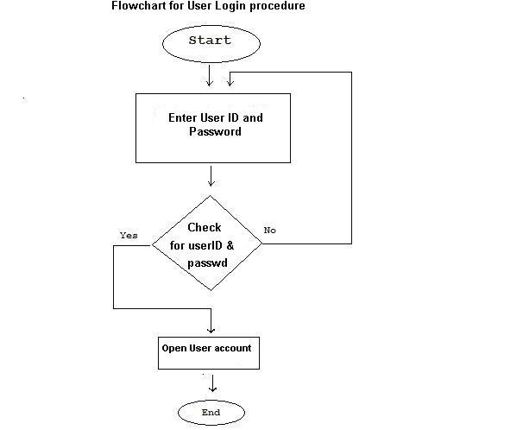

46

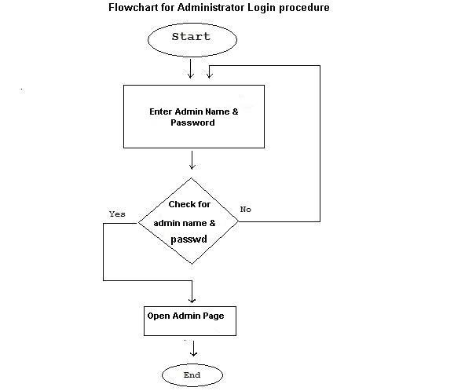

47

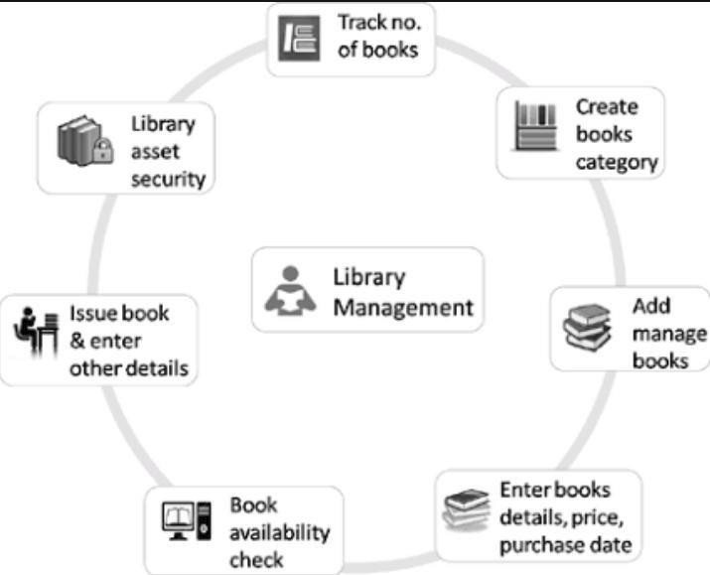

DATA FLOW DIAGRAM (DFD)

48

Data Dictionary

The Data Dictionary is very important part of the project through which we can know that where data are stored in the project. The Data Dictionary in this project is as below.

DATABASE NAME: Library

1. Admine

|  |  |  |  |  |  |
| --- | --- | --- | --- | --- | --- |
| Field | Type | collection | attribute | null | Default |
| Id | Int(2) |  |  | No | None |
| Username | Varchar(20) | Latin1.swesh-  id |  | No | None |
| Psw | Varchar(20) | Latin1.swesh-  id |  | No | None |

2. Book

Field Type Collection Attribute Null Default

49

Booked Int(4) Latin1.swesh_ci No None

Title Text No None

Author Varchar(50) Latin1.swesh_ci No None

Price Float No None

Publisher Varchar(50) Latin1.swesh_ci No None

Available Tinyint(4) No None

3. Borrow

|  |  |  |  |  |  |
| --- | --- | --- | --- | --- | --- |
| Field | Type | Collection | Attribute | null | Default |
| Bookid | Int(4) |  |  | No | None |
| Issueid | Int(3) |  |  | No | None |
| Issuedate | Datetime |  |  | No | None |
| Returnbook | Int(4) |  |  | No | None |
| Retuenid | int(3) |  |  | No | None |
| Retuendate | Datetime |  |  | No | None |

4. Member

|  |  |  |  |  |  |
| --- | --- | --- | --- | --- | --- |
| Field | Type | Collection | attribute | null | Default |
| Id | Int(3) | Latin1.swesh_ci |  | No | None |
| Firstname | Varchar(10) | Latin1.swesh_ci |  | No | None |
| Lastname | Varchar(10) | Latin1.swesh_ci |  | No | None |
| Position | Varchar(10) | Latin1.swesh_ci |  | No | None |
| Mobile | Varchar(10) | Latin1.swesh_ci |  | No | None |
| Email | Varchar(50) | Latin1.swesh_ci |  | No | None |
| Corce | Varchar(30) | Latin1.swesh_ci |  | No | None |

50

▪ A successful test is one that uncovers as-set undiscovered error.

THE ONLINE LIBRARY MANAGEMENT   
SYSTEM INFORMATION

General

What is online library management system?

The library management system a true marketplace for publishers, which   
means that you can find all the publishers selling their items under one   
platform.

There can also be independent sellers and distributors selling their items. This gamut of choices allows customers to choose to buy a book they want at the price they want to pay.

What can I get here?

You can find books, books and more books. Online library management system is a one-stop shop for you to look at, read about, compare and finally buy all books published in India by Indian publishers and also a wide selection of titles from USA and UK.

Are these books only in English?

51

No. TheBookShop.com has books in all languages from publishers of all sizes throughout the country.

We have books of all regional languages such as Punjabi, Hindi, Marathi, Gujarati, Bengali, Malayalam .

Online library management system Account   
and Registration

How do I purchase an item on The library management?

Purchasing an item is a simple 3-step process.

•

•

•

Create The account on The library management system Search and add items to your shopping cart

Enter your credit card details and submit the order That is it. The item you purchase will be delivered to your doorstep

Can I order without creating online library management system account?

No, you cannot order without creating The library management account.

Do I need a credit card to create The library management system account?

You do not need a credit card to create The library management account. Credit card information is required only at the time of ordering.

How do I create library management system account?

52

You can create The library management account using your email address and relevant information through My Account tab on our website.

Do you charge for creating The library management system account?

No, The library management account creation is free of any charge whatsoever.

What if I forget my password?

You can use our Forgot Password services to send/reset your password.

53

SCREENSHOT OF PROJECT

Fig 1.Log in(admin side)

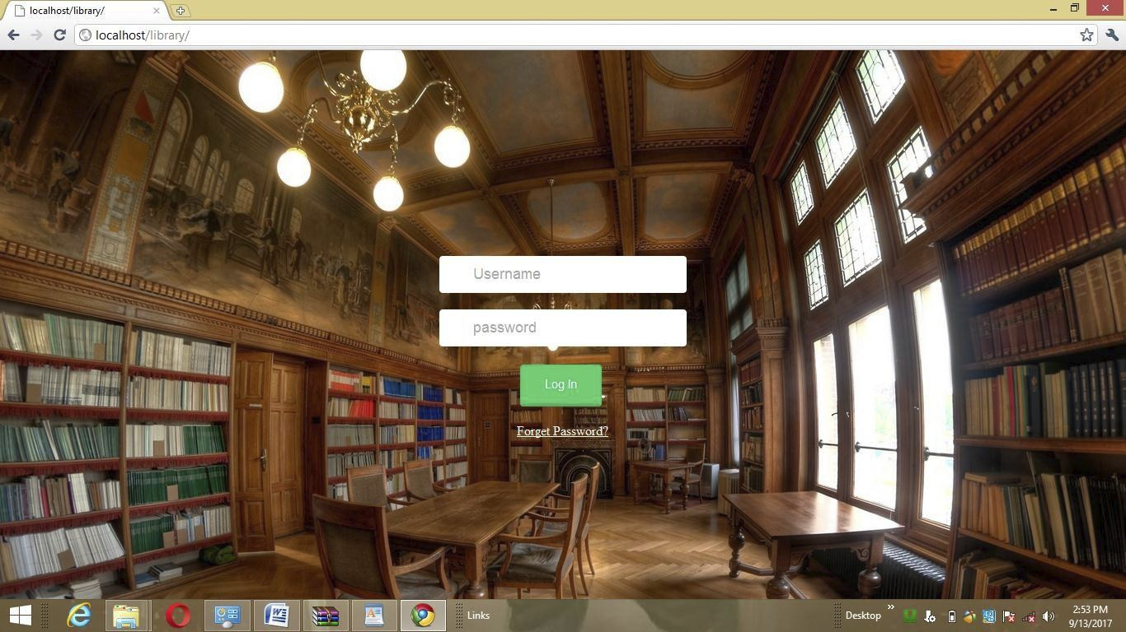

54

Fig 2. Admin

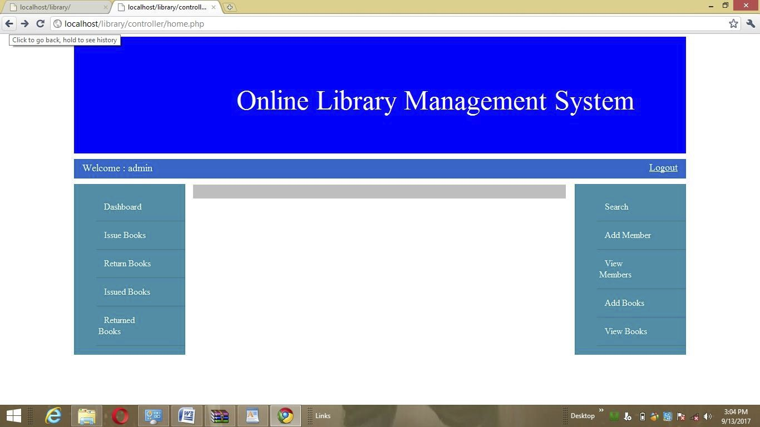

55

Fig 3. Issuebook

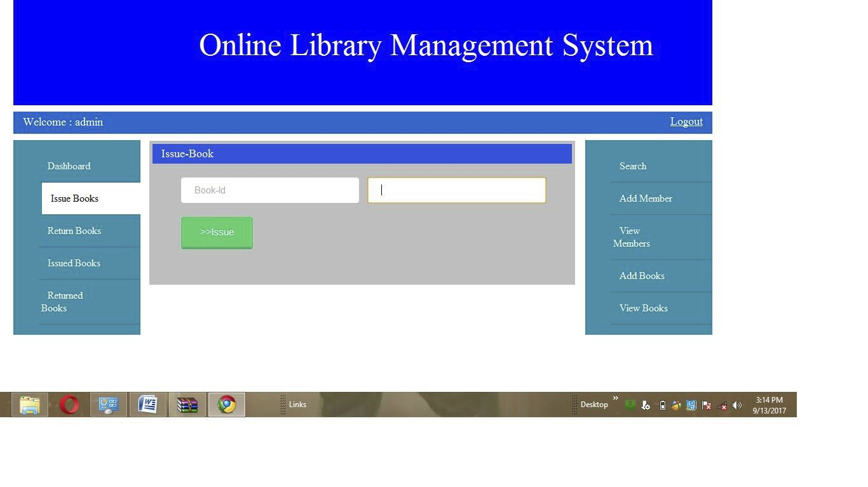

56



Fig 4. Return book

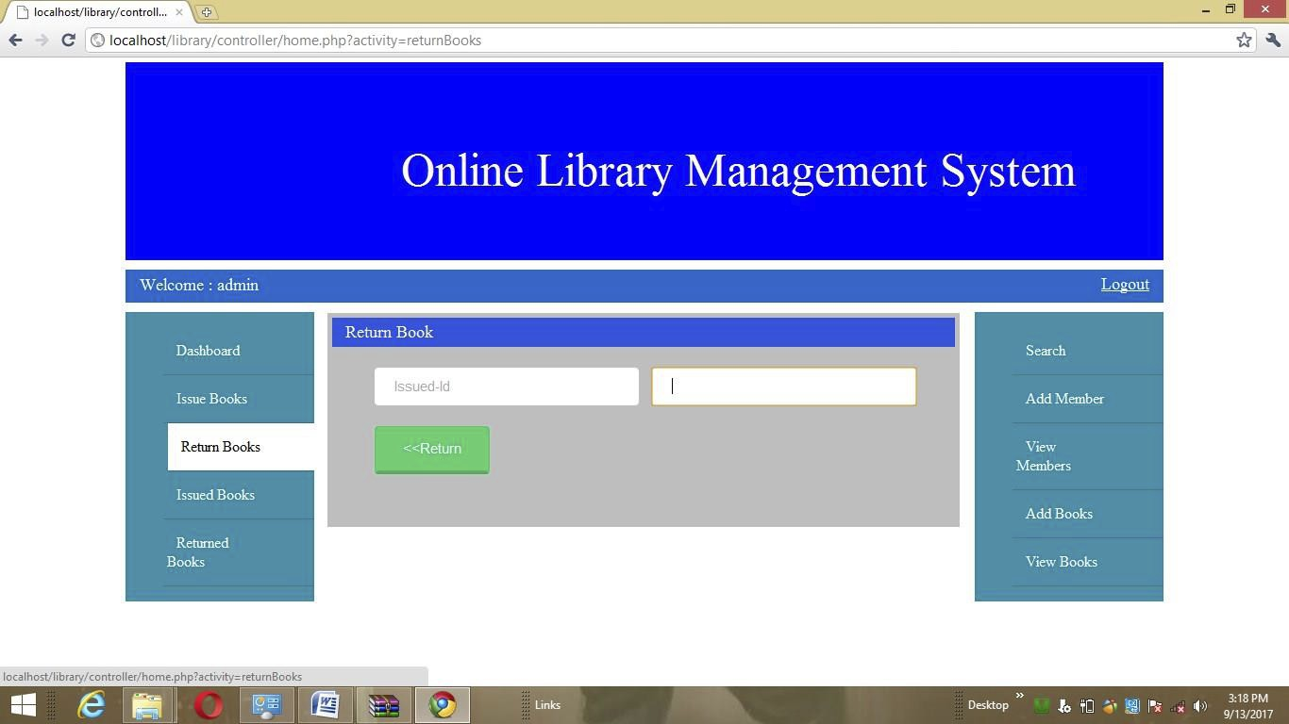

57

Fig 5. Issued book

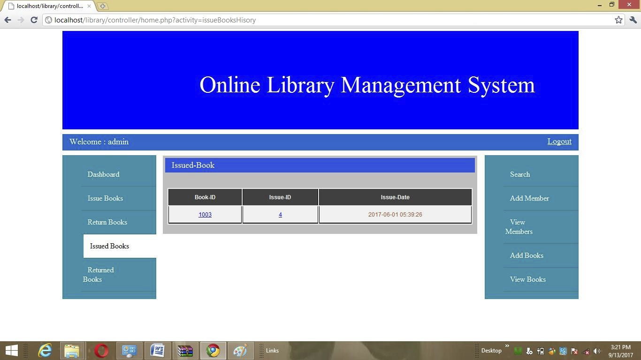

58

Fig 6. Returned book

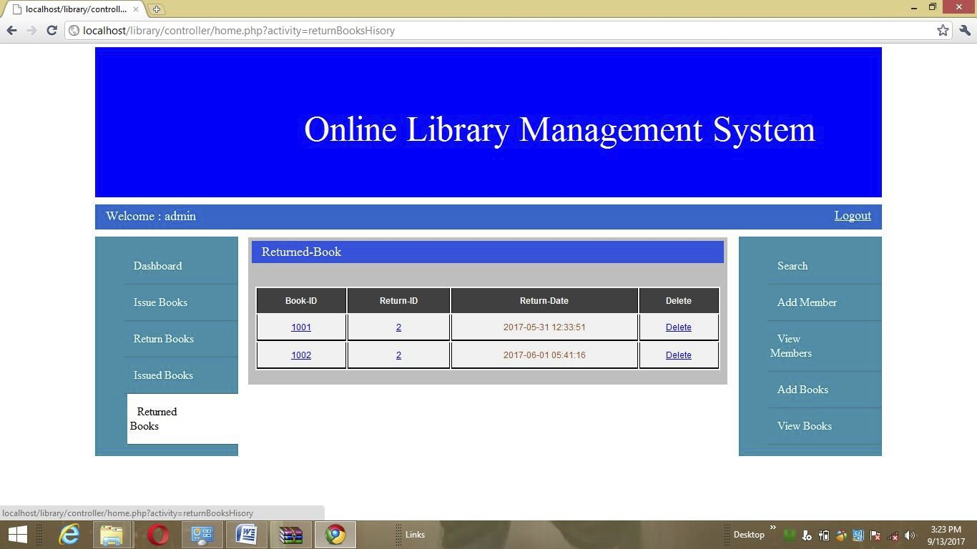

59

Fig 7. Search

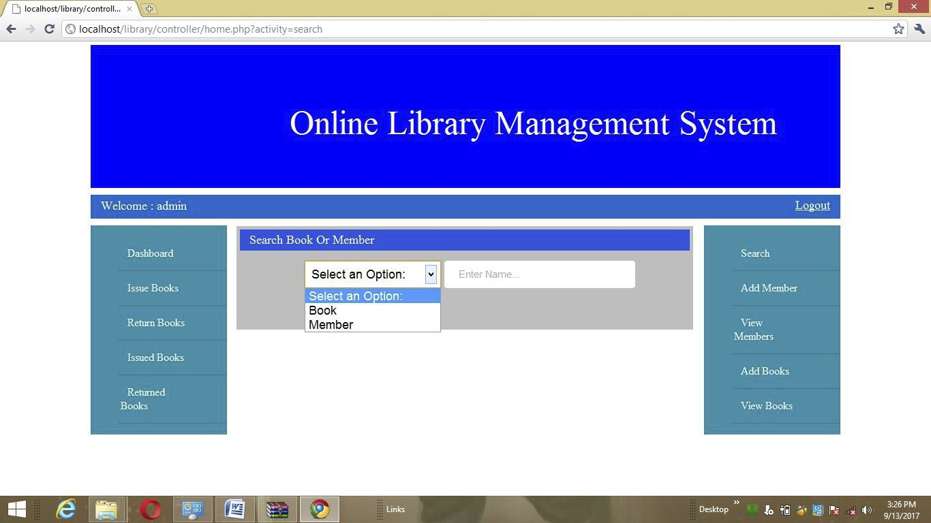

60

Fig 8. add member

\

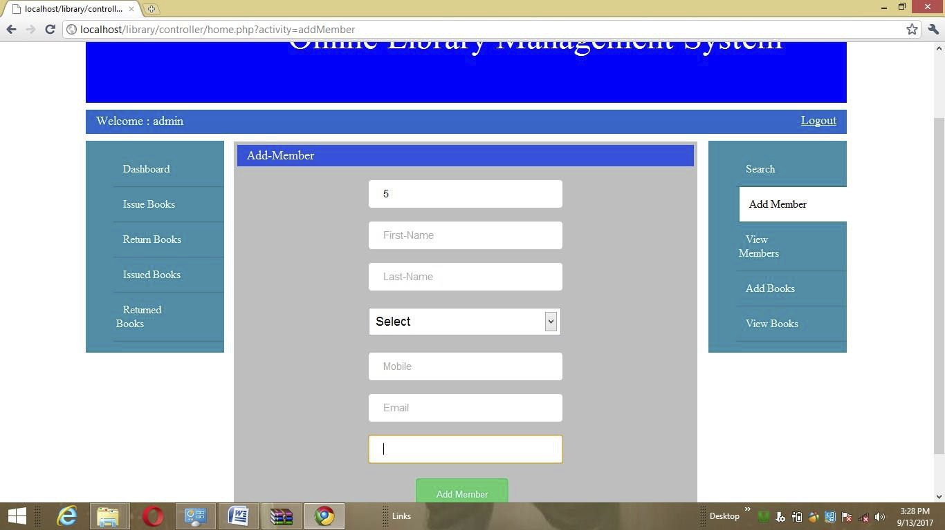

61

Fig 9. View member

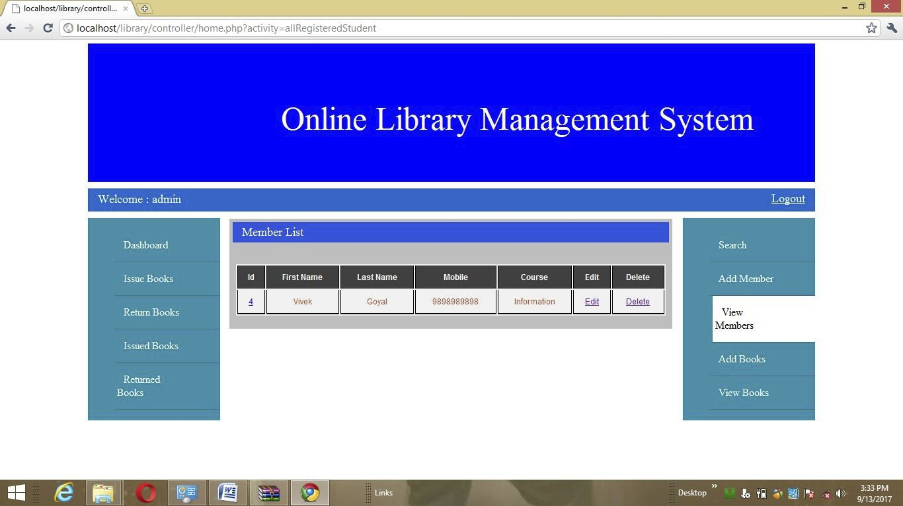

62

Fig 10. Add book

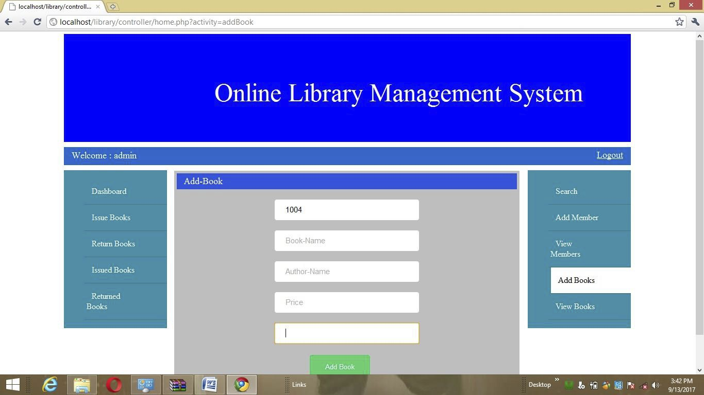

63

Fig 11. View book

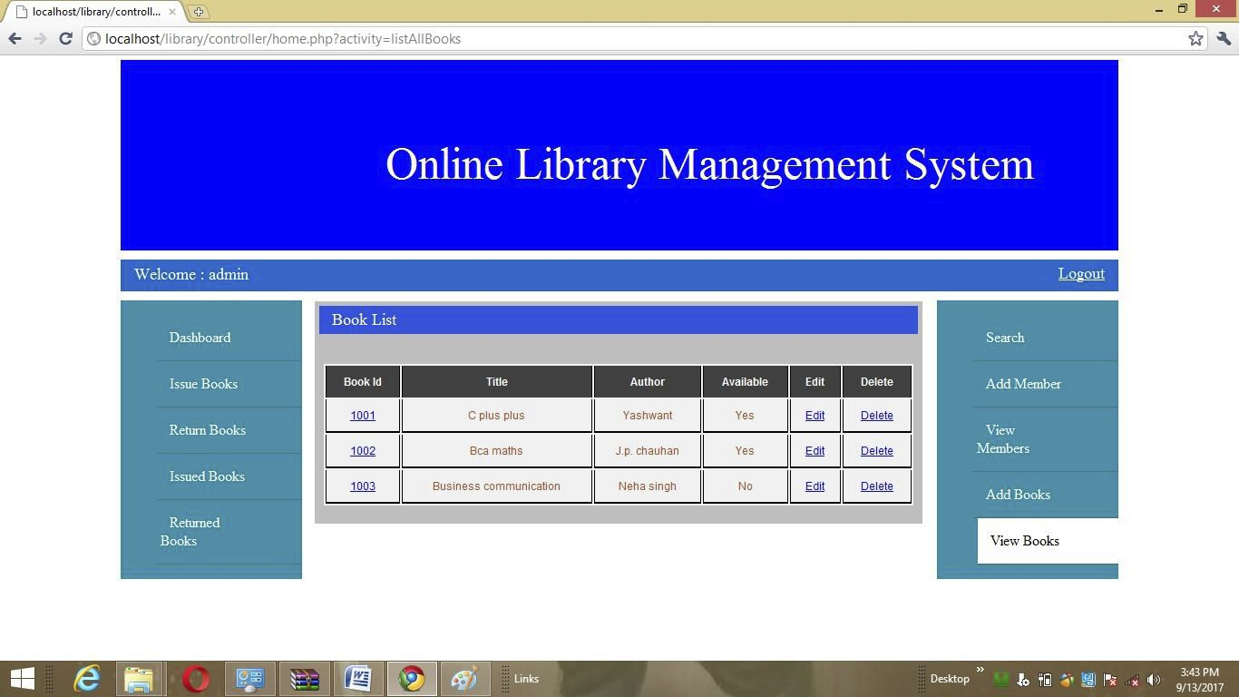

64



TESTING

12.1 Introduction

Software testing is the critical element of the software quality assurance and   
represents the ultimate review of specification, design, and code generation. Once the   
source code has been generated, software must be tested to uncover as many errors   
as possible before delivery to the users. The testing techniques for designing tests   
that

➢ Exercise the internal logic of the software component.

➢ Exercise the input and output domains of the program to uncover errors in program   
 function, behavior and performance.

12.2 Test methods

1. Defect Testing

Defect Testing is intended to find inconsistencies between a program and its Specification. These inconsistencies are due to the program faults or defects.

2. Black-box Testing

65



In Black-Box Testing or Functional Testing, the output of the module and software,   
is taken into consideration, i.e. whether the software gives proper output as per the   
requirements or not. The program just gets a certain input and its functionality is

examined by observing the output.

3. White-box Testing

• White Box testing is used as an important primary testing approach.

• White box testing methods like control testing, loop testing have been used to make   
 the software of increased reliability.

• In this testing know the internal logic of the software It is easy to identify the errors.

4. Performance Testing

Performance testing is designed to test the runtime performance of the system   
within the context of the system. These tests were performed as module level as   
well as system level. Individual modules were tested for required performance.

5. Condition Testing

• Condition testing is a test case design method that exercises the logical conditions   
 contained in a program module. If the condition is incorrect, then at least one part   
 of the condition is incorrect.

66

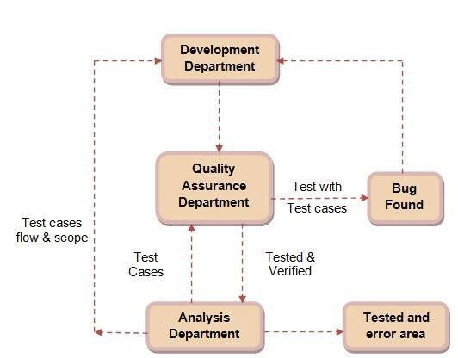

12.3 Test Plan

• Analysis and design department makes all analysis for the system and forward the   
 test cases flow of the system and scope of the system to development department.

• Development department implements all the forms and sends to QA department for   
 testing.

• QA department checks the form for test cases and also performs integrated testing.   
 If any error or bug found it returns to development department otherwise sends to   
 analysis department.

• Development department receives bug reports and after completing currently   
 running modules solves those bug reports.

• Analysis department receives error free forms and stores it permanent.

67

• After completing form level testing system integrity testing starts.

• Thus the system is tested per cycle and then it is developed further.

68

69

REFERENCES

Search Engines

[www.google.com](http://www.google.com/)

Visited Sites

[www.w3schools.com](http://www.w3schools.com/)   
[www.tutorialpoint.com](http://www.tutorialpoint.com/)   
[www.codingcage.com](http://www.codingcage.com/)   
[www.wikipedia.com](http://www.wikipedia.com/)

[www.jquery-ui.com](http://www.jquery-ui.com/)

70

FUTURE ENHANCEMENTS

• Facebook integrations.

• Parchase book

• Choose book

71

72